EXPERIMENTS

1. Static : HTML

[index.html]

<!DOCTYPE html>

<html lang="en">

<head>

    <title>Online Service</title>

    <link rel="stylesheet" href="styles.css">

</head>

<body>

    <h2>Welcome to Online Services</h2>

    <h2>Our Services</h2>

    <p>We provide excellent online solutions for your needs.</p>

    <button id="showFormButton" onclick="showForm()">Register</button>

    <form id="contactForm" onsubmit="return validateForm()">

        <label for="name">Name:</label><br>

        <input type="text" id="name" name="name"><br><br>

        <label for="email">Email:</label><br>

        <input type="email" id="email" name="email"><br><br>

        <label for="phone">Phone Number:</label><br>

        <input type="tel" id="phone" name="phone" placeholder="1234567890"><br><br>

        <label for="gender">Gender:</label><br>

        <select id="gender" name="gender">

            <option value="">Select Gender</option>

            <option value="Male">Male</option>

            <option value="Female">Female</option>

            <option value="Other">Other</option>

        </select><br><br>

        <input type="submit" value="Submit">

    </form>

    <div id="error-message"></div>

    <div id="success-message"></div>

    <script src="script.js"></script>

</body>

<footer>

    <p>&copy; 2025 Online Services. All rights reserved.</p>

</footer>

</html>

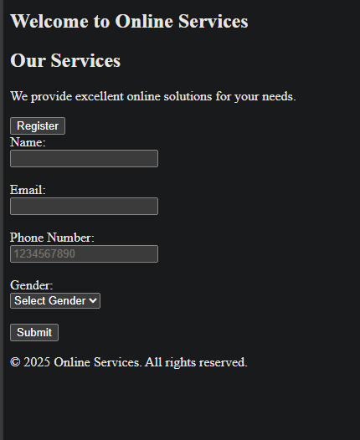

1. Static : CSS

[styles.css]

body {

    font-family: Arial, sans-serif;

    padding: 20px;

}

#showFormButton {

    padding: 10px 15px;

    background-color: #007BFF;

    color: white;

    border: none;

    cursor: pointer;

    font-size: 16px;

}

#showFormButton:hover {

    background-color: #0056b3;

}

#contactForm {

    display: none;

    max-width: 300px;

    margin: auto;

}

input[type="text"], input[type="email"], input[type="tel"], select {

    width: 100%;

    padding: 8px;

    margin: 5px 0;

}

input[type="submit"] {

    padding: 10px 15px;

    background-color: #4CAF50;

    color: white;

    border: none;

    cursor: pointer;

}

input[type="submit"]:hover {

    background-color: #45a049;

}

#error-message {

    color: red;

    margin-top: 20px;

}

#success-message {

    color: green;

    margin-top: 20px;

}



1. Dynamic : JS

[index.html]

<div class="time-container">

        <h1>Current Time</h1>

        <p id="time"></p>

    </div>

[script.js]

function showForm() {

    let form = document.getElementById("contactForm");

    form.style.display = "block";

    let button = document.getElementById("showFormButton");

    button.style.display = "none";

}

function updateTime() {

    const now = new Date();

    const timeString = now.toLocaleTimeString();

    document.getElementById("time").textContent = timeString;

}

setInterval(updateTime, 1000);

updateTime();





1. Dynamic : Form Validation

[script.js]

function validateForm() {

    let name = document.getElementById("name").value;

    let email = document.getElementById("email").value;

    let phone = document.getElementById("phone").value;

    let gender = document.getElementById("gender").value;

    let errorMessage = document.getElementById("error-message");

    let successMessage = document.getElementById("success-message");

    errorMessage.innerHTML = "";

    successMessage.innerHTML = "";

    if (name === "" || email === "" || phone === "" || gender === "") {

        errorMessage.innerHTML = "All fields (Name, Email, Phone, Gender) are required.";

        return false;

    }

    let emailPattern = /^[a-zA-Z0-9._-]+@[a-zA-Z0-9.-]+\.[a-zA-Z]{2,6}$/;

    if (!email.match(emailPattern)) {

        errorMessage.innerHTML = "Please enter a valid email address.";

        return false;

    }

    let phonePattern = /^\d{10}$/;

    if (!phone.match(phonePattern)) {

        errorMessage.innerHTML = "Please enter a valid phone number (e.g., 1234567890).";

        return false;

    }

    successMessage.innerHTML = "Form Submitted Successfully!";

    return false;

}

